Assignment 2
Why does the direction of KL divergence matter?
Forward vs Reverse KL and How it Works
Malik Muhammad Abdullah Hassan - 02621070
4-17-2026

Contents
Table of Figures 1
Motivation 2
Background 2
Main Analysis 3
Forward KL Divergence: The Mean-Seeking Behavior 3
Reverse KL Divergence: The Mode-Seeking Behavior 4
Practical Implications 4
Experimental Verification 4
Interpretation 5
Conclusion 6
Appendix References 7
Program Code 7
AI Log 9
Further Results and Materials 10
Reverse KL Valley Initialization Behavior 10
Reverse KL Multi-Start Behavior 11

Table of Figures
Figure 1: Example Distributions $Px$ and $Qx$ 2
Figure 2: Forward and Reverse KL Divergence Training on Q(x) 5
Figure 3: Reverse KL stuck in the symmetrical valley 10
Figure 4: Reverse KL plotted with different initializations 12

Table 1: Values for $Px$ and $Qx$ 3

Motivation
Kullback–Leibler (KL) divergence is the backbone of most modern data science and AI tools, measuring the distance between prediction and reality for many models. The lecture takes a deep dive into the theory behind KL divergence, and mentions one interesting point: Forward and Reverse KL divergence are not equal. This non-intuitive concept forms the basis of this report, where I will attempt to explain why this inequality exists, how it can be explained, and why it actually matters.
Background
In simple terms, KL divergence can be defined as the distance between two probability distributions. Given two distributions $P\left(x\right)$, the true distribution, and $Q\left(x\right)$, the predicted distribution, KL divergence measures the difference created when approximating $P$ from $Q$. Mathematically,
$$D_{KL}\left(P∥Q\right)=\sum_{xϵχ}{P\left(x\right)\log{\frac{P\left(x\right)}{Q\left(x\right)}}}$$
In a more theoretical sense, we can consider KL divergence as calculating the extra information, in bits or nats, produced when estimating $P$ by using $Q$. This can also be considered the difference between the Cross-Entropy and Entropy of the distributions. This can be explained through their respective results:
- Entropy calculates the minimum amount of information needed when using the true distribution $P\left(x\right)$, and
- Cross-Entropy calculates the actual amount of information when using the predicted distribution $Q\left(x\right)$.
The Forward KL is defined as above, and the Reverse KL is defined as follows:
$$D_{KL}\left(Q∥P\right)=\sum_{xϵχ}{Q\left(x\right)\log{\frac{Q\left(x\right)}{P\left(x\right)}}}$$
As a practical example, we may consider the following distributions $P\left(x\right)$ and $Q\left(x\right)$:
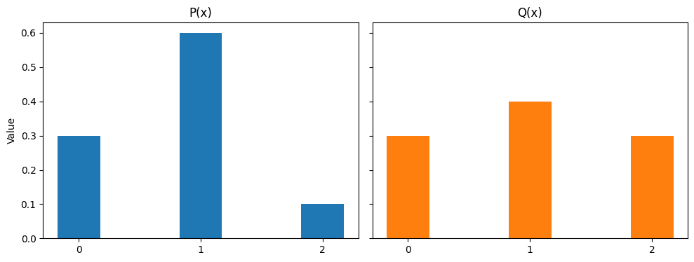
Figure 1: Example Distributions $P\left(x\right)$ and $Q\left(x\right)$
 | 0 | 1 | 2
P(x) | 0.3 | 0.6 | 0.1
Q(x) | 0.3 | 0.4 | 0.3
Table 1: Values for $P\left(x\right)$ and $Q\left(x\right)$
The Forward and Reverse KL can then be calculated as follows using the natural logarithm, giving us the information in nats:
$$D_{KL}\left(P∥Q\right)=0.3\ln{\frac{0.3}{0.3}}+0.6\ln{\frac{0.6}{0.4}}+0.1\ln{\frac{0.1}{0.3}}$$
$$D_{KL}\left(P∥Q\right)≈0.13$$
$$D_{KL}\left(Q∥P\right)=0.3\ln{\frac{0.3}{0.3}}+0.4\ln{\frac{0.4}{0.6}}+0.3\ln{\frac{0.3}{0.1}}$$
$$D_{KL}\left(Q∥P\right)≈0.17$$
This also reveals the interesting property that we discussed earlier: the Forward and Reverse KL divergence is unequal.
Main Analysis
We have now defined KL divergence and both of its Forward and Reverse variants. In this section, we will take a look into the why behind both of these directions and how their differences can be utilized.
Before a detailed discussion into either direction, it is useful to understand why they differ. As we discussed previously, KL divergence is a measure of the extra information between our two distributions. This can also be evaluated as the expectation:
$$D_{KL}\left(P∥Q\right)=\sum_{xϵχ}{P\left(x\right)\log{\frac{P\left(x\right)}{Q\left(x\right)}}}=E_{x∼P}\left[\log{P}\left(x\right)-\log{Q}\left(x\right)\right]$$
Or for the reverse case,
$$D_{KL}\left(Q∥P\right)=\sum_{xϵχ}{Q\left(x\right)\log{\frac{Q\left(x\right)}{P\left(x\right)}}}=E_{x∼Q}\left[\log{Q\left(x\right)}-\log{P\left(x\right)}\right]$$
As the expectation is taken with respect to the first distribution, the penalty for a mismatch is biased differently depending on the direction. This means that Forward and Reverse KL divergence will display different behaviors when applied.

Forward KL Divergence: The Mean-Seeking Behavior
In Forward KL, we take the expectation over the true distribution $P$. This means that whenever $P\left(x\right)>0$, $Q\left(x\right)$ must be significantly greater than zero to avoid a massive penalty. In the process of minimizing this loss, $Q$ will naturally try to cover all of the regions of $P$ more or less equally. This leads to an ‘averaging out’ behavior, effectively seeking the mean of the true distribution.

Reverse KL Divergence: The Mode-Seeking Behavior
In Reverse KL, we take the expectation over the predicted distribution $Q$. This means that whenever $P\left(x\right)≈0$, $Q\left(x\right)$ must also be zero to avoid the divergence penalty. This gives the Reverse KL the zero forcing property: it will ignore low valued regions in $P\left(x\right)$ and focus on the peaks of the distribution. Hence, the resulting distribution will have a mode seeking behavior, collapsing onto a single mode of $P$.

Practical Implications
Due to the opposing behaviors of Forward and Reverse KL, we can use them in differing contexts.
As Forward KL tends to cover all points in the true distribution, it is used in areas where the spread of the model must cover all data points no matter how rare they may be. The key area then becomes prediction. Given a dataset, we would like the model to learn every case present. When we are performing classification or regression analysis, the inherent function is the Forward KL divergence. However, it does have the limitation of over smoothing, which can lead the model to hallucinate connections and data where none might exist.
Reverse KL tends to capture the most important features in the distribution through the mode, so it is used in areas where fidelity is most important. This will include GANs, Reinforcement Learning models, variational autoencoders, and LLM training. You will note that all of these methods value feature accuracy more than other metrics. The mode-seeking behavior does mean that the diversity in the model is low, and it may miss outliers in the data.
Experimental Verification
To verify the natures of Forward and Reverse KL divergence, we have created a short experiment. The best way to show the difference is through a practical application, which will be shown below. The complete code for the program can be found in the appendix.
We have chosen a simple 1D bimodal Gaussian mixture model to represent the ‘true’ distribution $P$, and unimodal Gaussian model to represent the ‘prediction’ distribution $Q$. $P$ has peaks at mean values of $μ_{1}=-3$ and $μ_{2}=3$, with $σ_{P}=0.8$. The model $Q$ is based on two learnable parameters of $μ$ and $σ$. In mathematical terms,
$$P\left(x\right)=\frac{1}{2}\left(\frac{1}{\sqrt{2π{σ_{P}}^{2}}}\exp\left(-\frac{{\left(x-μ_{1}\right)}^{2}}{2{σ_{P}}^{2}}\right)+\frac{1}{\sqrt{2π{σ_{P}}^{2}}}\exp\left(-\frac{{\left(x-μ_{2}\right)}^{2}}{2{σ_{P}}^{2}}\right)\right)$$
$$Q\left(x\right)=\frac{1}{\sqrt{2πσ^{2}}}\exp\left(-\frac{{\left(x-μ\right)}^{2}}{2σ^{2}}\right)$$
The experiment will now be to train $μ$ and $σ$ in $Q\left(x\right)$ using both Forward and Reverse KL divergence as loss functions, and see how the trained functions differ from the true distribution. The optimizer in use is Adam, with a learning rate of 0.02 across 1500 steps. To ensure that both behaviors are observed, we will try two initializations for $μ$, at 0 for Forward KL and at 2 for Reverse KL. This is important as Reverse KL can get stuck in the valley between the two peaks due to their symmetry if initialized at 0. This behavior can be seen in the Further Results section of the appendix.
The figure below shows the results of our experiment. For verification purposes, the training loss has also been plotted to ensure that both models have converged.
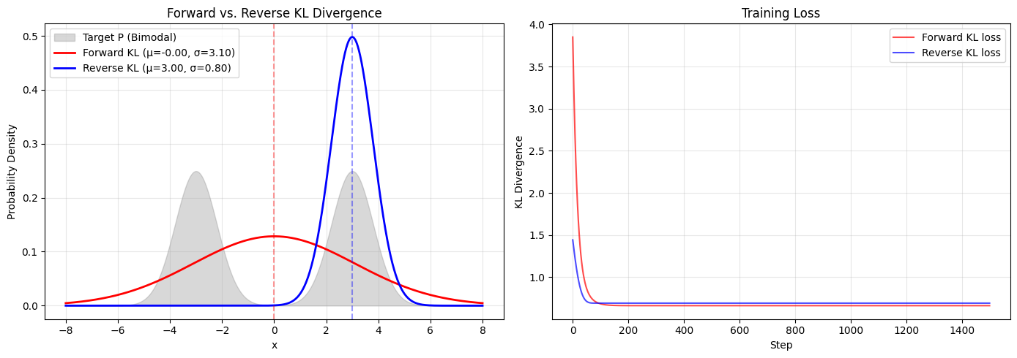
Figure 2: Forward and Reverse KL Divergence Training on Q(x)
We can see that we get widely different behaviors from the Forward and Reverse KL models. The results will be discussed in the next section.
Interpretation
The model has converged completely for both cases, as we can see on the training loss curves.
As we discussed in the theoretical portion of this paper, we can now see both behaviors for KL divergence: for the Forward case, the model stretches over the whole distribution, covering the mean and expanding to include all the points possible, and for the Reverse case, the model picks one mode and puts all of its mass around that point. This provides a direct proof for the mathematical behavior we discussed in the previous section.
This experiment also highlights some limitations of both methods. For the Forward KL case, we can see that the model actually predicts the highest values where there is zero value in the true distribution. Even though all points in the distribution are captured, the defining features have been lost. In the Reverse KL case, it has only captured one mode of the distribution. Even though one feature has been captured completely, it is missing a large portion in the form of the second mode. It becomes a choice of choosing between one of two errors, not being able to perfectly reconstruct the target in either.
Conclusion
The direction of KL divergence is not just a mathematical curiosity - it directly influences how models adhere to data and optimize predictions. Forward KL is all inclusive: it forcefully covers all data, making it suitable for general data estimation. Reverse KL is selective: it choses to prioritize the most important parts, making it suitable for areas where quality matters. In deep learning, awareness of this asymmetry allows one to choose the right model for the right task, depending on whether to prioritize coverage or precision.

Appendix
References
- Kullback, S.; Leibler, R.A. (1951). "On information and sufficiency". Annals of Mathematical Statistics. 22 (1): 79–86. doi:10.1214/aoms/1177729694
- Kullback, Solomon (1959), Information Theory and Statistics, John Wiley & Sons. Republished by Dover Publications in 1968; reprinted in 1978: ISBN 0-8446-5625-9.
- Mehra, V. (n.d.). KL-divergence explained: Intuition, formula, and examples | datacamp. Datacamp. https://www.datacamp.com/tutorial/kl-divergence

Program Code
import torch
import torch.nn as nn
import torch.optim as optim
import matplotlib.pyplot as plt
import numpy as np
# Target distribution P: Bimodal Gaussian Mixture with well-separated peaks
def p_pdf(x):
mu1, mu2 = -3.0, 3.0
sigma = 0.8
p1 = torch.exp(-0.5 * ((x - mu1) / sigma)**2) / (sigma * np.sqrt(2 * np.pi))
p2 = torch.exp(-0.5 * ((x - mu2) / sigma)**2) / (sigma * np.sqrt(2 * np.pi))
return 0.5 * (p1 + p2)

# Approximation model Q: Single Gaussian with learnable mean and std
class GaussianModel(nn.Module):
def __init__(self, init_mu, init_log_sigma=0.0):
super().__init__()
self.mu = nn.Parameter(torch.tensor([init_mu]))
self.log_sigma = nn.Parameter(torch.tensor([init_log_sigma]))

def pdf(self, x):
sigma = torch.exp(self.log_sigma)
return torch.exp(-0.5 * ((x - self.mu) / sigma)**2) / (sigma * np.sqrt(2 * np.pi))

@property
def sigma(self):
return torch.exp(self.log_sigma).item()
def train_kl(mode, init_mu, lr=0.02, steps=1500):
"""Train a Gaussian Q to approximate bimodal P using Forward or Reverse KL."""
model = GaussianModel(init_mu)
optimizer = optim.Adam(model.parameters(), lr=lr)

x_grid = torch.linspace(-10, 10, 2000)
dx = x_grid[1] - x_grid[0]
p_x = p_pdf(x_grid) # P is fixed, compute once

losses = []

for i in range(steps):
optimizer.zero_grad()
q_x = model.pdf(x_grid)

if mode == "Forward":
# KL(P || Q) = sum P(x) * log(P(x)/Q(x)) * dx
loss = torch.sum(p_x * (torch.log(p_x + 1e-10) - torch.log(q_x + 1e-10))) * dx
else:
# KL(Q || P) = sum Q(x) * log(Q(x)/P(x)) * dx
loss = torch.sum(q_x * (torch.log(q_x + 1e-10) - torch.log(p_x + 1e-10))) * dx

loss.backward()
optimizer.step()
losses.append(loss.item())

return model, losses
# Forward KL: init at center is fine — it will spread to cover both modes
m_fwd, loss_fwd = train_kl("Forward", init_mu=0.0)

# Reverse KL: init near one mode to break symmetry
m_rev, loss_rev = train_kl("Reverse", init_mu=2.0)

print(f"Forward KL: Mean = {m_fwd.mu.item():.2f}, StdDev = {m_fwd.sigma:.2f}")
print(f"Reverse KL: Mean = {m_rev.mu.item():.2f}, StdDev = {m_rev.sigma:.2f}")
x = np.linspace(-8, 8, 1000)
x_t = torch.from_numpy(x).float()

fig, axes = plt.subplots(1, 2, figsize=(14, 5))

# Left: Distribution fits
ax = axes[0]
ax.fill_between(x, p_pdf(x_t).numpy(), color='gray', alpha=0.3, label='Target P (Bimodal)')
ax.plot(x, m_fwd.pdf(x_t).detach().numpy(), 'r-', lw=2,
label=f'Forward KL (\u03bc={m_fwd.mu.item():.2f}, \u03c3={m_fwd.sigma:.2f})')
ax.plot(x, m_rev.pdf(x_t).detach().numpy(), 'b-', lw=2,
label=f'Reverse KL (\u03bc={m_rev.mu.item():.2f}, \u03c3={m_rev.sigma:.2f})')
ax.axvline(m_fwd.mu.item(), color='red', ls='--', alpha=0.4)
ax.axvline(m_rev.mu.item(), color='blue', ls='--', alpha=0.4)
ax.set_title('Forward vs. Reverse KL Divergence')
ax.set_xlabel('x')
ax.set_ylabel('Probability Density')
ax.legend()
ax.grid(alpha=0.3)

# Right: Loss curves
ax = axes[1]
ax.plot(loss_fwd, 'r-', alpha=0.7, label='Forward KL loss')
ax.plot(loss_rev, 'b-', alpha=0.7, label='Reverse KL loss')
ax.set_title('Training Loss')
ax.set_xlabel('Step')
ax.set_ylabel('KL Divergence')
ax.legend()
ax.grid(alpha=0.3)

plt.tight_layout()
plt.show()

AI Log
The following screenshots show the prompts used during the writing of this paper. The complete response has been cut for brevity.
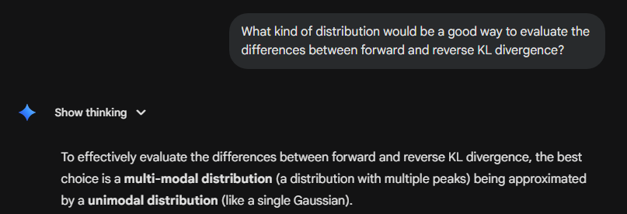
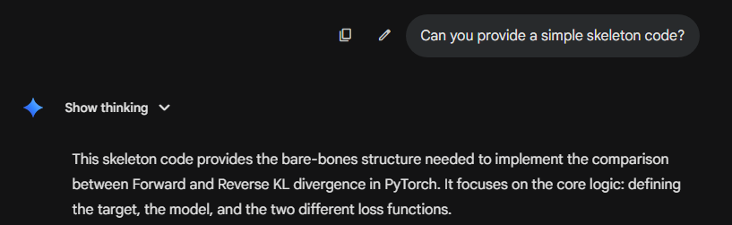
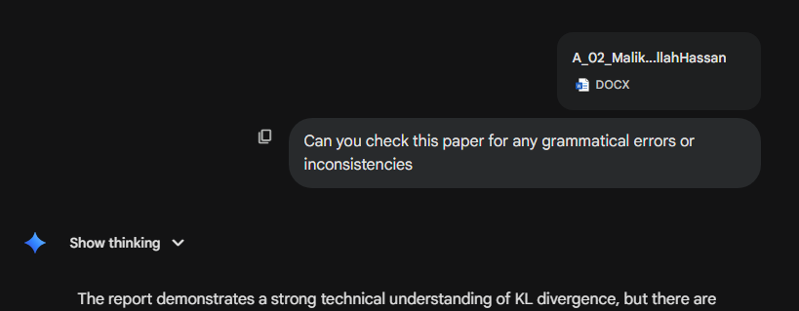

Further Results and Materials

Reverse KL Valley Initialization Behavior
This section illustrates the importance of initialization when training in the Reverse KL case. If the mean is not initialized to a value other than zero, the model cannot break free of the symmetry, and does not display its mode seeking behavior. This can be visually seen in the graph below. The same does not apply for Forward KL, as it is already averaging over the symmetry.
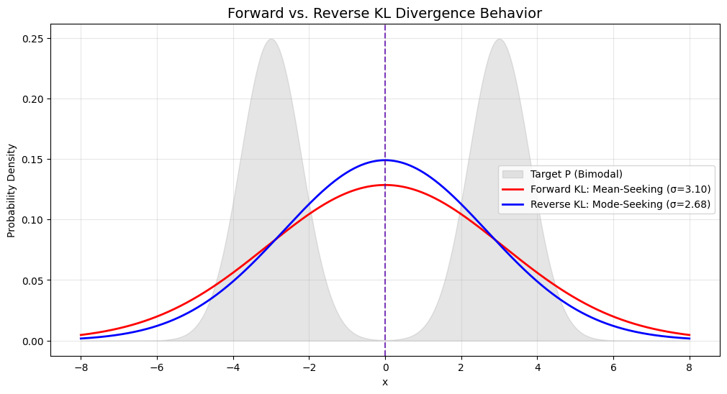
Figure 3: Reverse KL stuck in the symmetrical valley

Reverse KL Multi-Start Behavior
This section is going to further illustrate the mode-seeking property of Reverse KL through implementation at different starting points. Theoretically, Reverse KL should always collapse onto the mode of the distribution, and with multiple modes, it should choose the closest one. The verification code and result for this property can be seen below. The code is an extension of the already created script and should be run together with the main body.

Code
init_mus = [-4.0, -1.5, 1.5, 4.0]
# High-contrast colors; pairs share a family (cool = lands on left mode, warm = lands on right)
# but use very different shades within each pair for visibility
colors = ['#0000a2', '#50ad9f', '#bc272d', '#e9c716'] # blue, green, red, yellow
linestyles = ['--', ':', '--', ':']
linewidths = [3, 4, 3, 4]

fig, ax = plt.subplots(figsize=(10, 5))
ax.fill_between(x, p_pdf(x_t).numpy(), color='gray', alpha=0.3, label='Target P')

for mu0, color, ls, lw in zip(init_mus, colors, linestyles, linewidths):
m, _ = train_kl("Reverse", init_mu=mu0)
ax.plot(x, m.pdf(x_t).detach().numpy(), color=color, lw=lw, linestyle=ls,
label=f'init \u03bc={mu0:.1f} \u2192 \u03bc={m.mu.item():.2f}, \u03c3={m.sigma:.2f}')

ax.set_title('Reverse KL: Mode-Seeking from Different Initializations')
ax.set_xlabel('x')
ax.set_ylabel('Probability Density')
ax.legend()
ax.grid(alpha=0.5)
plt.tight_layout()
plt.show()

Results
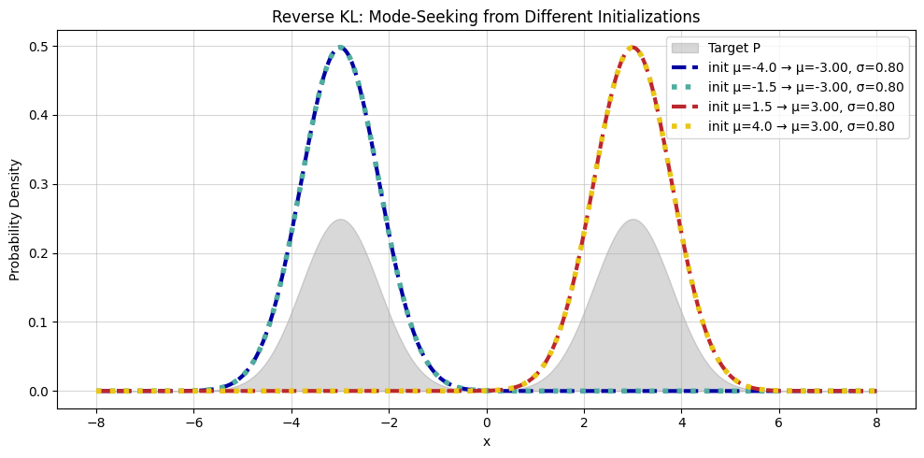
Figure 4: Reverse KL plotted with different initializations
As we can see for four different initializations, Reverse KL always collapses onto the closest mode.

